|  |  |  |  |  |
| --- | --- | --- | --- | --- |
| **Lab #2** | **ENGR 332** | **Analog Circuits & System Design (Lab)** | **2019 Spring** | **R. Brouwer** |

Lab Experiments Dates for Section A: 02/14 & 02/21 (Thursday, for two weeks)

Lab Report Due: At the beginning of the following lab

**Topic:** Single-Transistor Amplifier Analysis

**Objectives:**

1. Study the effects of an emitter-degeneration resistance on the performance of a BJT amplifier and measure the characteristics of a single-transistor (BJT) amplifier.
2. Experimental results are to be compared to the theoretical calculations to **determine the accuracy of the experiment**.

**Equipment:** Computer Lab PC, Signal Generator SFG-2110, Oscilloscope, Power supply, Decade Resistance box

**Resources:**

1. Microelectronic Circuits, 6th Edition, by Sedra and Smith, Chapter 6.6

**Background Theory:**

Transistors, as the name implies, are “*transfer*-resistors”. An input signal modulates a small current or voltage across the input terminals of the transistor. This control signal then modulates an output path at a much larger current level. The larger current signal can be used to pull a large signal voltage across a load. The ratio of signal in and signal out is a voltage *transfer* gain.

Amplifiers, however, have operational constraints. Just because we develop larger signal voltages at the output does not imply that our amplifier is capable of lighting a 60W bulb. The amplifier’s ability to transfer power is constrained by its internal resistance and output current at the output. We call this resistance the “output resistance” (*Rout*), and it is something we can measure. The transistor amplifier also has a finite input resistance (*Rin*).

So the basic transfer characteristics of an amplifier that we wish to measure are:

*Rin* = Input Resistance

*Rout* = Output Resistance

*Av* = *v*o/*v*i = Voltage Gain

as we represent by the two-port model of an amplifier shown by Figure 1. Note that this is a small-signal equivalent model of a BJT, which uses a dependent voltage source instead of a current source. It simply represents the overall amplifier. The voltage source and output resistance form a Thevenin equivalent circuit. The output signal is labeled as *vo.*

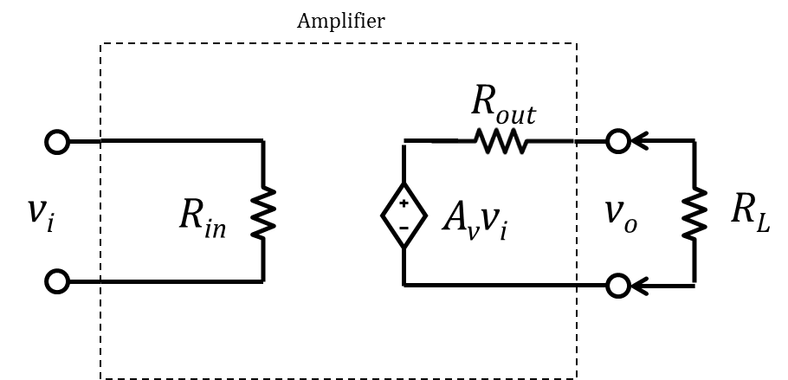

**Figure 1. “Amplifier” Block Diagram**

These signals, and the amplifier transfer characteristics, are all based on small increments of voltage at the input and output, for which $∆V_{I}=v_{i}$ and $∆V_{O}=v_{o}$.Therefore, input and output resistances are not just equivalent resistances, but are slopes. For example, $R_{in}={{dV}_{I}}/{{dI}_{I}}$. So measurement cannot be done by a DMM. We will need to use other techniques. The purpose of this experiment is to measure amplifier characteristics and identify the factors that define them. And in the process learn some of the special measurement techniques needed.

**Experiments:**

**(Students need to perform experiments individually and to get the results individually.)**

**Exp.1** **Circuit setup:** The amplifier topology that we will consider is the one shown in Figure 2. This topology is called a *common emitter* (CE) with a $R_{e}$ configuration, and is a general-purpose amplifier topology.

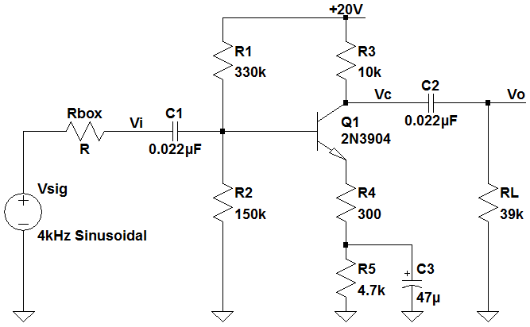

**Figure 2. Common emitter amplifier circuits**

Notice that the amplifier is a set of components (resistancesand transistor) strung in between two voltage rails, just like those associated with a prototyping board. In thiscase the upper rail is provided by the 20V (external) power supply, and the lower rail is at ground. Therefore, it is a single output power supply.

Follow the steps to build the circuit of Figure 2 on a prototyping board. Transistor Q1 is the 2N3904. Visit digikey.com to search its datasheet and pinouts (Emitter, Base, and Collector).

(Digikey Part #: 2N3904FS-ND)

Step 1: Print out Figure 2. Write your name on it. You will need to attach it to the report.

Step 2: Get the components (resistors, capacitors, and a transistor).

Step 3: Verify the values of resistors with a multimeter (ohm measurement). **Record the values.**

Step 4: Verify the values of capacitors with a capacitance meter. **Record the values.**

Step 5: Use jumper wires shown. Use of relatively short jumper (3~4 inches long) wires around the base input terminal will help to minimize the noises, because the input resistance of CE amp is high (~greater than $30 kΩ$). High resistance means that it tends to pick up a small signal. For example, when the input current is $0.1 mA$ and input resistance is $30 kΩ$, then the input voltage results in 3 V. Note that the max input voltage (without distortion) of the audio amplifier of Lab 1 was about 300 mV. If you use a long jumper wire on the high resistance node (i.e., the base terminal of CE amp), it would act like an antenna catching signals including noises (white Gaussian) around the circuits.

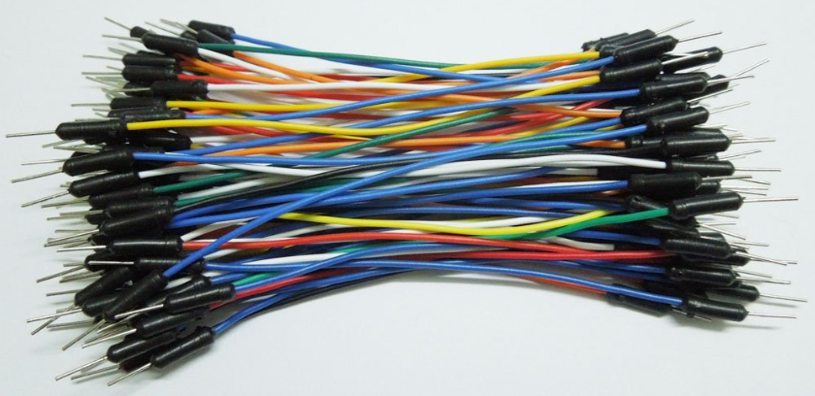

Step 6: Make a connection and mark it off with a highlighter or color pen one at a time on Figure 2, which you printed out in Step 1. Notice that if you lay out the circuit on the breadboard with roughly the same topology as the circuit diagram, there is less likelihood for connection errors. Be sure to leave resistances *R4* and *R5* readily accessible, for exchange with other resistance values. Set the resistance box at $999.99 kΩ$ (max value) until further notice. Repeat Step 6 until you mark off all the connection on Figure 2. Show the highlighted schematic to the instructor before you apply any voltage to your circuits. Keep the highlighted schematic and attach to the lab report. As a matter of fact, this is the most critical step of the lab. If you ignore this step, and as a result of that, if you have errors in your construction, then it would take hours and hours to debug any errors.

Be sure that everything is connected up properly before turning on the power supply.

Notice that you have a large capacitance as shown in Figure 3 that has a polarity associated with it, and must be placed in the circuit as marked. This type capacitance is called an electrolytic capacitance, and must be employed as a polarized component because it has a chemical sponge inside with anode and cathode. A bar across the side of the capacitor is usually used to indicate the negative (-) terminal. Measure the capacitance with a DMM.

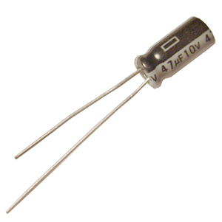

Negative (-)

A bar indicating a Negative (-) terminal

Positive (+)

Figure 3. Electrolytic Capacitor

Step 7: Attach a T-shape BNC connector to the output of the signal generator SFG-2110. Use a BNC cable (BNC at one end and black & red alligator clips at the other end) to apply 4 kHz sine wave with $200 {mV}_{p-p}$ to the input of the circuits. Adjusting the source should be done before connecting it to the circuit as the loading of the circuit can change the output voltage of the source. Use a BNC-to-BNC to connect the generator output to the CH1 of LeCroy oscilloscope. Use an oscilloscope probe to measure voltages on the circuit. Connect the probe to CH2. Set CH1 to “Auto” and CH2 probe from “Auto” to “10:1” scale.

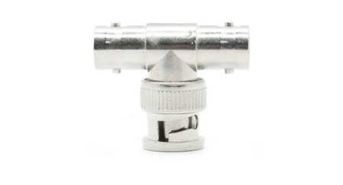

**Exp.2** **Basic Operation:** Power up the circuit with +20 V. As a check you should use the DMM (with the probe leads) to probe the circuit and check the voltages at the collector (*VC*), base (*VB*) and the emitter (*VE*) of the transistor. *VB* should be approximately 5.0~5.9 V and *VE* should be approximately 0.7 V below that. If they are not reasonably close to these values, you should turn off your power supply and carefully examine your circuit wiring, especially the power connection.

**Table 1. Bias Voltage and Supply Voltage**

|  |  |  |  |
| --- | --- | --- | --- |
| $V_{B}$, measured  (Input DC bias) | $V_{E}$, measured | $V_{C}$, measured  (Output DC bias) $$V_{C}≈V_{CC}/2$$ | $V_{CC}$, measured |
|  |  |  |  |

Put a shorting wire (jumper wire: banana-banana) across the resistance box. This will set $R_{sig}=0$, which would be the ideal case of the output resistance of the source. Apply an input signal (4 kHz) of peak-peak amplitude 200mV using the scope. Do not use the DMM to measure 4 kHz AC signal. Connect CH2 of the oscilloscope to the output point $v_{o}$ of the amplifier. Output peak-peak amplitude should be considerably larger than that of the input amplitude (approximately 4~5Vpp). Using the scope scales and cursors, measure the ratio $v_{o,pp}$ vs. $v_{i, pp}$. This ratio is the gain *AV* of the amplifier. Fill in the blanks.

**Table 2. Exp2 (Gain Measurement with given $R_{4}$ and $R_{5}$)**

|  |  |  |  |  |  |
| --- | --- | --- | --- | --- | --- |
| $R_{4}$, measured | $R_{5}$, measured | $R_{L}$, measured $$(\sim 39 kΩ)$$ | $v_{i}$, input voltage (peak – peak) => Use “Top - Base” measurement on the oscilloscope | $v_{o}$, output voltage (peak – peak) => Use “Top - Base” measurement on the oscilloscope  (with $R_{L}=measured$) | $$A_{v}$$ (with $R_{L}=measured$) |
|  |  |  |  |  |  |

**Exp.3** **Input and Output Resistance:** Now remove the shorting wire from the resistance box to measure the input resistance. This means we want to add non-zero value of $R_{sig}$. You should note that $v_{i}$ drops in amplitude due to the voltage divider. Set the amplitude of *vsig* (Function Generator) to 200mVp-p (peak-to-peak). Reduce the Rbox (resistance *Rx*) until the amplitude at *vi* becomes half of *vsig*. *Hint:* You may find it convenient to concurrently monitor *vsig* and *vi* by connecting CH2 to *vin*, and setting CH1 and CH2 to the same scale. The value of *Rx* for which *vi = (1/2) * vsig* is *Rin*. This is a voltage divider circuit. The principle is illustrated by Figure 4. Record the value of *Rx* in the table below.

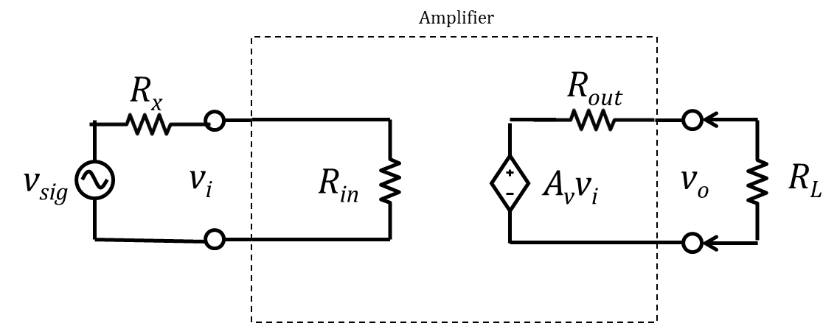

Figure 4. **Input** Resistance Measurement

The input resistance of the common-emitter amplifier can be increased by including an unbypassed resistor (with no parallel capacitance) in the emitter lead. This emitter-degeneration resistance provides other performance improvements at the expense of reduced voltage gain.

Fill in the blanks.

**Table 3. $R_{in}$ of Exp.3**

|  |  |  |  |  |  |
| --- | --- | --- | --- | --- | --- |
| $R_{4}$, measured | $R_{5}$, measured | $v_{i}$, input voltage (peak – peak) => Use “Top - Base” measurement on the oscilloscope  (~100 mV) | $v_{o}$, output voltage (peak – peak) => Use “Top - Base” measurement on the oscilloscope  (with $R_{L}=measured$) | $R_{L}=measured$, $(\sim 39 kΩ$) | $$R_{in}$$ $$25 KΩ$$ $$\sim 35 KΩ$$ |
|  |  |  |  |  |  |

Now let’s measure the output resistance. Remove the R-box and connect a shorting wire between *vsig* and *vi* (on the proto board) as shown in Figure 5. Remove the CH2 probe from *vi*. Remove *RL* (). Record the value *vo* without *RL* in Table 4 (no resistance box attached to the output). Move the connections of the R-box so that they are emplaced across *RL*. This procedure effectively replaces *RL* by the R-box. Connect the CH2 probe to *vo.*

With the input signal at 200mVp-p, monitor *vo* as a function of the setting of *Rx*. Start with *Rx* = and reduce it in value until the amplitude of *vo* drops by a factor of 2. This value is the value of *Rout* and is another entry in your data table. The principle is illustrated by Figure 5.

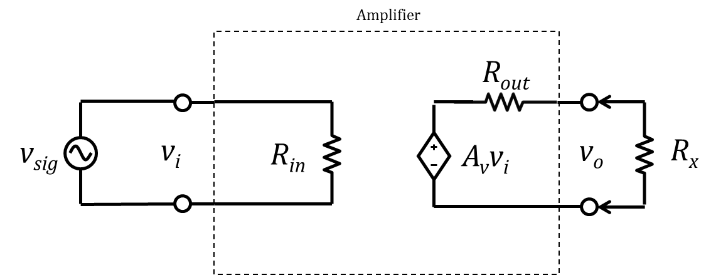

Figure 5. **Output** Resistance Measurement

**Table 4. $R_{out}$ of Exp.3**

|  |  |  |  |  |  |
| --- | --- | --- | --- | --- | --- |
| $R_{4}$, measured | $R_{5}$, measured | $v_{i}$, input voltage (peak – peak) => Use “Top - Base” measurement on the oscilloscope: | $v_{o}$, output voltage (peak – peak) => Use “Top - Base” measurement on the oscilloscope  (with $R_{L}=measured$) | $$v_{o}$$ (without $R_{L}$) | $$R_{out}$$ |
|  |  | ~200 mV (b/c of short circuit between $v_{sig} and v_{i}$) |  |  |  |

**Exp.4** **Testing Other Component Values:**

**4.1** Restore the circuit configuration of **Exp1**. Replace *R4* and *R5*, respectively by *R4* = and *R5* = . The series resistance of $R_{e}$ is then 680 + 20 + 4.3 k = $5.0 kΩ$. Repeat the measurement process as used in **Exp2** to determine (1) voltage gain *AV*. Repeat **Exp3** to determine (2) *Rin* and *Rout* for these new values of *R4* and *R5*.

Fill in the blanks.

**Table 5a. Exp.4.1 (Gain $A_{v}$)**

|  |  |  |  |  |  |
| --- | --- | --- | --- | --- | --- |
| $R_{4}$, measured | $R_{5}$, measured | $R_{L}$, measured $$(\sim 39 kΩ)$$ | $v_{i}$, input voltage (peak – peak) => Use “Top - Base” measurement on the oscilloscope | $v_{o}$, output voltage (peak – peak) => Use “Top - Base” measurement on the oscilloscope  (with $R_{L}=measured$) | $$A_{v}$$ (with $R_{L}=measured$) |
|  |  |  |  |  |  |

**Table 5b. Exp.4.1 ($R_{in}$)**

|  |  |  |  |  |  |
| --- | --- | --- | --- | --- | --- |
| $R_{4}$, measured | $R_{5}$, measured | $v_{i}$, input voltage (peak – peak) => Use “Top - Base” measurement on the oscilloscope  (~100 mV) | $v_{o}$, output voltage (peak – peak) => Use “Top - Base” measurement on the oscilloscope  (with $R_{L}=measured$) | $R_{L}=measured$, $(\sim 39 kΩ$) | $$R_{in}$$ $$40 KΩ$$ $$\sim 50KΩ$$ |
|  |  |  |  |  |  |

**Table 5c. Exp.4.1 ($R_{out}$)**

|  |  |  |  |  |  |
| --- | --- | --- | --- | --- | --- |
| $R_{4}$, measured | $R_{5}$, measured | $v_{i}$, input voltage (peak – peak) => Use “Top - Base” measurement on the oscilloscope: | $v_{o}$, output voltage (peak – peak) => Use “Top - Base” measurement on the oscilloscope  (with $R_{box}=measured$) | $$v_{o}$$ (without $R_{L} or R_{box}$) | $$R_{out}$$ |
|  |  | ~200 mV (b/c of short circuit between $v_{sig} and v_{i}$) |  |  |  |

**4.2** Restore the circuit configuration of **Exp1**. Replace *R4* and *R5*, respectively by *R4* = and *R5* = . The series resistance of $R_{e}$ is then 1 k + 3.9 k +0.1 k = $5.0 kΩ$. Repeat the measurement process as used in **Exp2** and **Exp3** to determine (1) voltage gain *AV*, and (2) *Rin* and *Rout* for these new values of *R4* and *R5*.

Fill in the blanks.

**Table 6a. Exp.4.2 (Gain $A_{v}$)**

|  |  |  |  |  |  |
| --- | --- | --- | --- | --- | --- |
| $R_{4}$, measured | $R_{5}$, measured | $R_{L}$, measured $$(\sim 39 kΩ)$$ | $v_{i}$, input voltage (peak – peak) => Use “Top - Base” measurement on the oscilloscope | $v_{o}$, output voltage (peak – peak) => Use “Top - Base” measurement on the oscilloscope  (with $R_{L}=measured$) | $$A_{v}$$ (with $R_{L}=measured$) |
|  |  |  |  |  |  |

**Table 6b. Exp.4.2 ($R_{in}$)**

|  |  |  |  |  |  |
| --- | --- | --- | --- | --- | --- |
| $R_{4}$, measured | $R_{5}$, measured | $v_{i}$, input voltage (peak – peak) => Use “Top - Base” measurement on the oscilloscope  (~100 mV) | $v_{o}$, output voltage (peak – peak) => Use “Top - Base” measurement on the oscilloscope  (with $R_{L}=measured$) | $R_{L}=measured$, $(\sim 39 kΩ$) | $$R_{in}$$ $$50 KΩ$$ $$\sim 60 KΩ$$ |
|  |  |  |  |  |  |

**Table 6c. Exp.4.2 ($R_{out}$)**

|  |  |  |  |  |  |
| --- | --- | --- | --- | --- | --- |
| $R_{4}$, measured | $R_{5}$, measured | $v_{i}$, input voltage (peak – peak) => Use “Top - Base” measurement on the oscilloscope: | $v_{o}$, output voltage (peak – peak) => Use “Top - Base” measurement on the oscilloscope  (with $R_{box}=measured$) | $$v_{o}$$ (without $R_{L} or R_{box}$) | $$R_{out}$$ |
|  |  | ~200 mV (b/c of short circuit between $v_{sig} and v_{i}$) |  |  |  |

**4.3** Restore the circuit configuration of **Exp1**. Replace *R4* and *R5*, respectively by *R4* = and *R5* = . The series resistance of $R_{e}$ is then 2 k + 3 k = $5 kΩ$. Repeat the measurement process as used in **Ex2** and **Ex3** to determine (1) voltage gain *AV*, and (2) *Rin* and *Rout* for these new values of *R4* and *R5*.

Fill in the blanks.

**Table 7a. Exp.4.3 (Gain $A_{v}$)**

|  |  |  |  |  |  |
| --- | --- | --- | --- | --- | --- |
| $R_{4}$, measured | $R_{5}$, measured | $R_{L}$, measured $$(\sim 39 kΩ)$$ | $v_{i}$, input voltage (peak – peak) => Use “Top - Base” measurement on the oscilloscope | $v_{o}$, output voltage (peak – peak) => Use “Top - Base” measurement on the oscilloscope  (with $R_{L}=measured$) | $$A_{v}$$ (with $R_{L}=measured$) |
|  |  |  |  |  |  |

**Table 7b. Exp.4.3 ($R_{in}$)**

|  |  |  |  |  |  |
| --- | --- | --- | --- | --- | --- |
| $R_{4}$, measured | $R_{5}$, measured | $v_{i}$, input voltage (peak – peak) => Use “Top - Base” measurement on the oscilloscope  (~100 mV) | $v_{o}$, output voltage (peak – peak) => Use “Top - Base” measurement on the oscilloscope  (with $R_{L}=measured$) | $R_{L}=measured$, $(\sim 39 kΩ$) | $$R_{in}$$ $$60 KΩ$$ $$\sim 70KΩ$$ |
|  |  |  |  |  |  |

**Table 7c. Exp.4.3 ($R_{out}$)**

|  |  |  |  |  |  |
| --- | --- | --- | --- | --- | --- |
| $R_{4}$, measured | $R_{5}$, measured | $v_{i}$, input voltage (peak – peak) => Use “Top - Base” measurement on the oscilloscope: | $v_{o}$, output voltage (peak – peak) => Use “Top - Base” measurement on the oscilloscope  (with $R_{box}=measured$) | $$v_{o}$$ (without $R_{L} or R_{box}$) | $$R_{out}$$ |
|  |  | ~200 mV (b/c of short circuit between $v_{sig} and v_{i}$) |  |  |  |

**Exp.5 Analysis:**

1. The following relationships should be of help in your analysis of the data.
$$R_{in}=R_{1}||R_{2}||R_{iB}, where R_{iB}=(β+1)(\frac{1}{g_{m}}+R_{4})$$

$$R_{out}=r_{out}||R_{3}, where r_{out}=r_{o}+(1+g_{m}r_{o})(r_{π}||R_{4})$$

$$A_{V}=-g_{m}(R_{3}|\left|R_{L}\right)(\frac{1}{1+g_{m}R_{4}})$$

2. Use MathCAD or Excel to perform calculations. Use the results of your four $R_{in}$ measurements to determine the best fit value (average) of the forward current gain $β$ (or $h_{fe}$) for the 2N3904 transistor. This parameter is one of the internal parameters for the transistor, and it should be on the order of 70 – 150. This value varies as $I_{C}$ varies as shown in Figure 6. Hint: You can determine four $R_{iB}$ by four measured $R_{in}$. Then, four $β$ can be calculated by four $R_{iB}$. Use $g_{m}=40m \frac{A}{V}or 1/{g_{m}}=25 Ω$. In addition, use the measured value of $R_{1}, R_{2}, R_{3}, R_{4}, R_{5}, and R_{L}$.

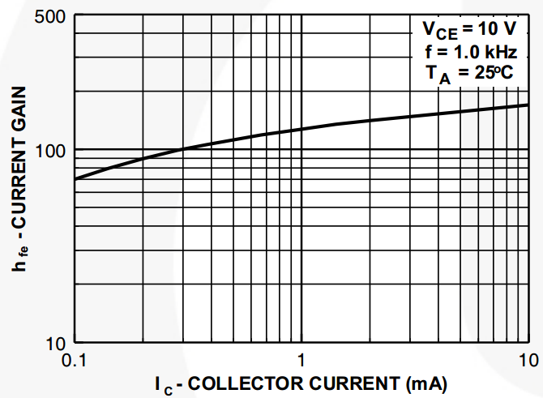

Figure 66. Current Gain ( $β$ or $h_{fe}$)

1. Use MathCAD or Excel to perform ${R_{in}, R}_{out} and A_{v}$ calculations. Use the standard value of $R_{1}, R_{2}, R_{3}, R_{4}, R_{5}, and R_{L}$. Use the average value of $β$ found in **Exp5.2**, in order to calculate four $R_{iB}$ and $R_{in}$. Compare these calculations with your measurements ($R_{in},R_{out} and A_{v}$). Comment on the comparisons. Note that $r_{o} is approximately 100 kΩ$.
2. Make a plot of *Rin* (y-axis) vs. *R4* (x-axis), comparing measurements against theory. Use the values in **Table 4, 5, 6**, and **7**.
3. Make a plot of |*AV*| (absolute value of Av)vs. *R4* (x-axis), comparing measurements against theory. Use the values in **Table 4, 5, 6**, and **7**.
4. What are your conclusions about the dependence of *AV, Rin,* and *Rout* on the emitter feedback resistance *R4*?

**Exp.6 Explain why there is a discrepancy between the theoretical and measured values.**

**Exp.7**

* Make sure that you have files saved on your H: drive before you log off lab computers.

**Exp.8 Cleanup:** When you have completed all of the required measurements after two weeks of lab, remove the parts from the prototyping board and return them to the parts box in the parts cabinet for use your brethren in the next lab. **Throwing them on a pile on the shelf or leaving them at your lab station is not a good practice – they need to go back in the proper drawers!**

## *Report: Your reports will be used for the ABET assessment. See the next page.*

**Single-Transistor Amplifier Analysis**

**OBJECTIVE:** /* Re-phrase the given objective. Make your own objective. */

* *Refer to “ABET Assessment” below and the Objectives in the handout above.*

**THEORY and PROCEDURE: /\*** Correctly explain the principles and assumptions that underlie the experiment and calculations. (Exp 1, 2, 3, and 4). Record all of procedures, setups and measurements. Include necessary drawings/diagrams/Tables. */

* **Exp1: Circuit Setup: (Step 1, Step2, … etc.)**

//Explains the principles and assumptions that underlie the experiment and calculations.

1. Connect CH2….
2. Adjust the resistance box while measuring $v_{in}$
3. Read the resistance and record it.
4. …..

* **Exp2: Basic Operation and Limits of Operation: (Step 1, Step2, … etc.)**

//Explains the principles and assumptions that underlie the experiment and calculations.

**1)**

**2)**

**3)**

**4)….**

* **Exp3: Input and Output Resistance: (Step 1, Step2, … etc.)**

//Explains the principles and assumptions that underlie the experiment and calculations.

**1)**

**2)**

**3)**

**4)….**

* **Exp4: Testing Other Component Values: (Step 1, Step2, … etc.)**

//Explains the principles and assumptions that underlie the experiment and calculations.

**1)**

**2)**

**3)**

**4)….**

* *Refer to “ABET Assessment” below.*

**RESULTS and DISCUSSION: /\*** Generate tables and plots. Show connection between theory and experimental results. Explain the plots (e.g. value increased or decreased? Comment on the comparisons. Also, **provide error analysis (explain why the discrepancy?)** */

* *Refer to “ABET Assessment” below.*

**CONCLUSION: /\*** Technical conclusion. */

-The end of template

**ABET Assessment:**

***(g) … and ability to communicate truthfully and effectively (writing).***

Activity/Assignment: one laboratory report is assessed for truthful and effective communication using the following common rubric:

**Purpose/Objective**

|  |  |
| --- | --- |
| Score | Description |
| **4 – Excellent** | Student accurately and concisely explains the purpose of the experiment. Specifically, the student   * ***Acknowledges the need*** to critically compare theory and experimental results. * Uses appropriate technical terms. * Uses high quality writing including correct grammar, punctuation, spelling, tone, and formatting. |
| 3 – Good | Student explains the purpose of the experiment but fails to meet one of the bullet items for a score of 4. |
| 2 – Fair | Student explains the purpose of the experiment but fails to meet two of the bullet items for a score of 4. |
| 1 - Poor | Student explains the purpose failing to meet all three bullet items for a score of 4 or fails to explain the purpose of the experiment. |

**Theory and Procedure**

|  |  |
| --- | --- |
| Score | Description |
| **4 – Excellent** | Student accurately and concisely explains the theory and experimental procedure. Specifically, the student   * Correctly explains the principles and assumptions that underlie the experiment and calculations. * Explains the procedure in such a way that another student could repeat the experiment. * Uses appropriate technical terms and uses high quality writing including correct grammar, punctuation, spelling, tone, and formatting. |
| 3 – Good | Student explains the theory and experimental procedure but fails to meet one of the bullet items for a score of 4. |
| 2 – Fair | Student explains the theory and experimental procedure but fails to meet two of the bullet items for a score of 4. |
| 1 - Poor | Student explains the theory and experimental procedure failing to meet all three bullet items for a score of 4 or fails to explain the theory and experimental procedure of the experiment. |

**Results and Discussion**

|  |  |
| --- | --- |
| Score | Description |
| **4 – Excellent** | Student accurately and concisely explains the results and interprets them in a way consistent with the physical world. Specifically, the student   * Provides a meaningful connection to the purpose and shows connection between theory and experimental results. * Presents graphs and/or tables of engineering results (not raw data) in proper format. * Provides proper and meaningful error analysis. |
| 3 – Good | Student presents the results and discussion but fails to meet one of the bullet items for a score of 4. |
| 2 – Fair | Student presents the results and discussion but fails to meet two of the bullet items for a score of 4. |
| 1 - Poor | Student presents the results and discussion failing to meet all three bullet items for a score of 4 or fails to present results and discussion entirely. |

Here is a ***check list*** for you. (You need to include this list in the report.)

$⊡$ Use the template on pp. 11 & 12.

$⊡$**Cover page**

$⊡$**Page** numbers (place them on the bottom of the pages, if you don’t mind.)

$⊡$“Objectives” was not being copied and pasted. (**no numbering** or **bullet points**)

$⊡$ Figure numbers/captions were **under** the figure.

$⊡$ A capital F (as in **Figure 1**) was used in the report (e.g. “The result is shown in Figure 1.”)

$⊡$ Do not include any black background figures in your report.

$⊡$ Table numbers/captions were on **top** of the table.

$⊡$ A capital T (as in **Table 1**) was used in the report (e.g. “The result is shown in Table 1.”)

$⊡$ Figures, tables, and its captions were placed in the **center** of page.

$⊡$**White** background plots from PSpice.

$⊡$ Conclusion addressed the Objectives.